Ex. No. : 06 | Date:
Register No.: 231701501 | Name: Sri Vishnu K

SVM Classifier
Aim:
To implement Support Vector Machine (SVM) classifier for classification of the Iris dataset.
PROGRAM:
import pandas as pd
import numpy as np
import matplotlib.pyplot as plt

from google.colab import files
from sklearn.model_selection import train_test_split
from sklearn.preprocessing import StandardScaler, LabelEncoder
from sklearn.svm import SVC
from sklearn.metrics import accuracy_score, confusion_matrix, classification_report

# Upload dataset
uploaded = files.upload()

# Load dataset
data = pd.read_csv("Iris.csv")

# Drop Id column if present
if 'Id' in data.columns:
data = data.drop('Id', axis=1)

# Split features and target
X = data.iloc[:, :-1].values
y = data.iloc[:, -1].values

# Encode target labels
le = LabelEncoder()
y = le.fit_transform(y)

# Train-test split
X_train, X_test, y_train, y_test = train_test_split(
X, y, test_size=0.2, random_state=42
)

# Feature scaling
scaler = StandardScaler()
X_train = scaler.fit_transform(X_train)
X_test = scaler.transform(X_test)

# SVM model
svm = SVC(kernel='rbf', gamma='scale')

# Train model
svm.fit(X_train, y_train)

# Predictions
y_pred = svm.predict(X_test)

# Evaluation
accuracy = accuracy_score(y_test, y_pred)

print("Accuracy:", accuracy)
print("\nConfusion Matrix:\n", confusion_matrix(y_test, y_pred))
print("\nClassification Report:\n", classification_report(y_test, y_pred))

# Visualization (first two features)
plt.figure()

plt.scatter(X[:, 0], X[:, 1], c=y)
plt.xlabel("Sepal Length")
plt.ylabel("Sepal Width")
plt.title("Iris Data Classification")
plt.show()
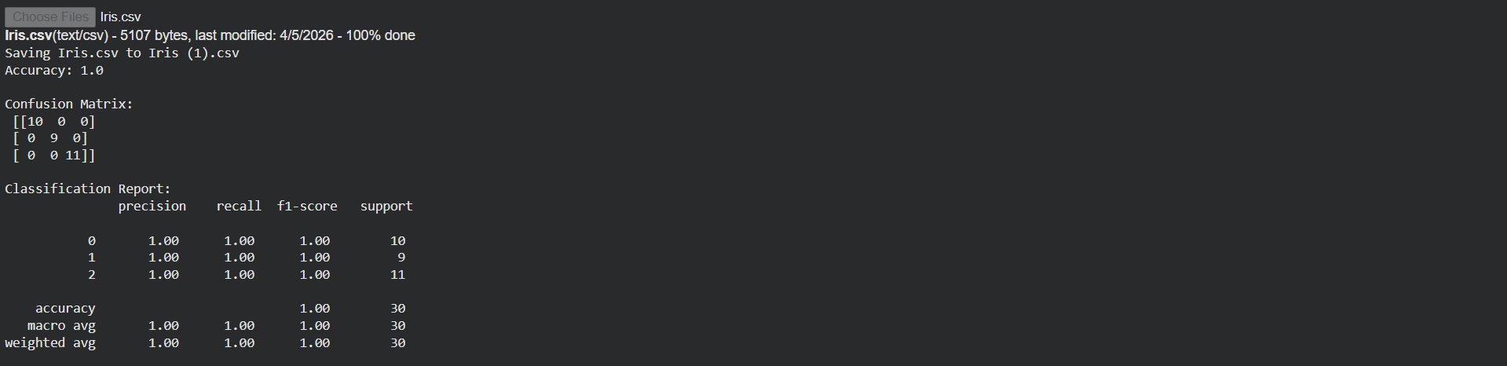

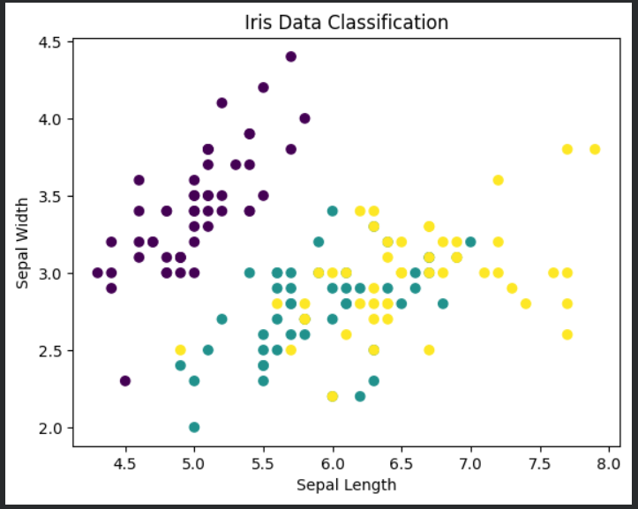

Result:
The SVM classifier was successfully implemented and provided accurate classification of Iris species with good performance.

